CIS-4560 Term Project Tutorial

1. Go to https://www.transtats.bts.gov/DL_SelectFields.asp?Table_ID= and click the download button shown.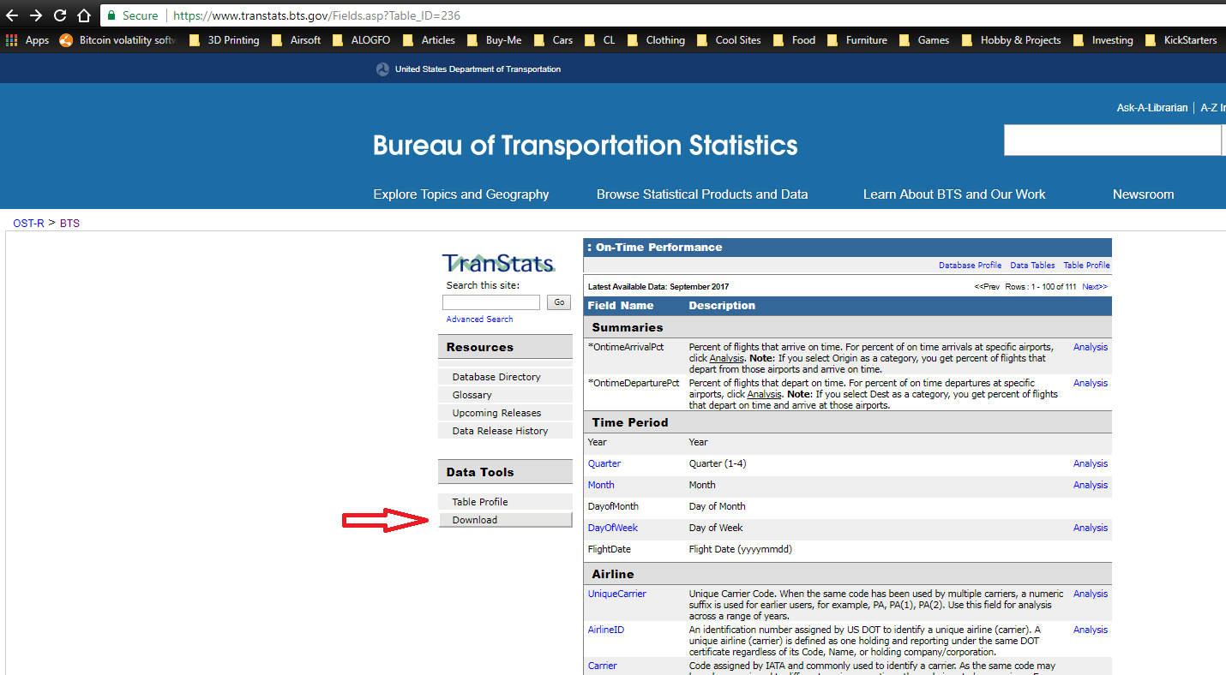
2. Select all the fields and date ranges for the data you wish to work with, then click download.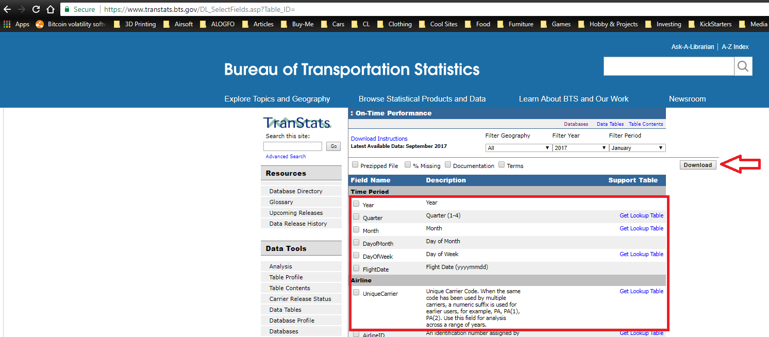

1. Next you must upload your data into HDFS. If you are hosting your data on a server you can simply use cURL or wGET. But for our example we will use the Ambari browser window. Login to BigInsights and click the button shown in the top right to open the Ambari file browser.

i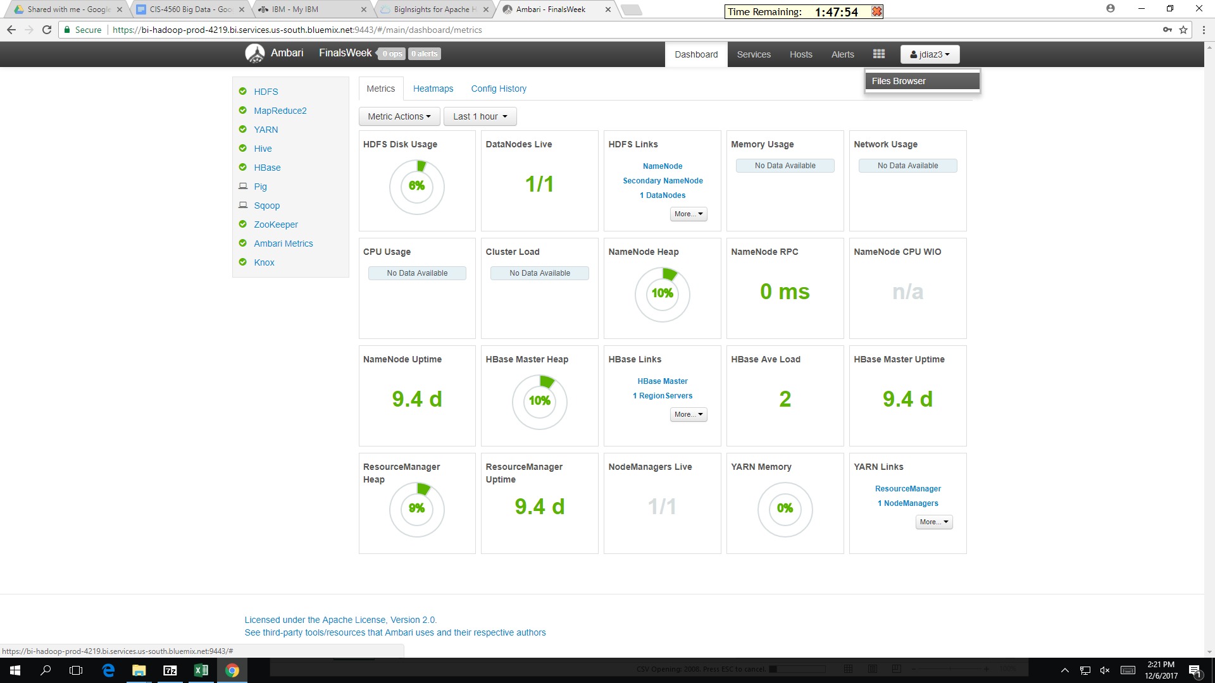

4. Navigate the the directory you want to upload your data to, most likely /user/<username>/<data directory>/. Then click the upload button in the top right corner.

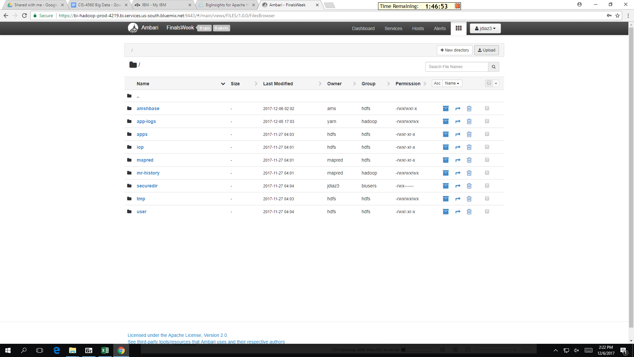

5. Example of which directory the CSVs will uploaded to, in order to use them in a Hive External table.

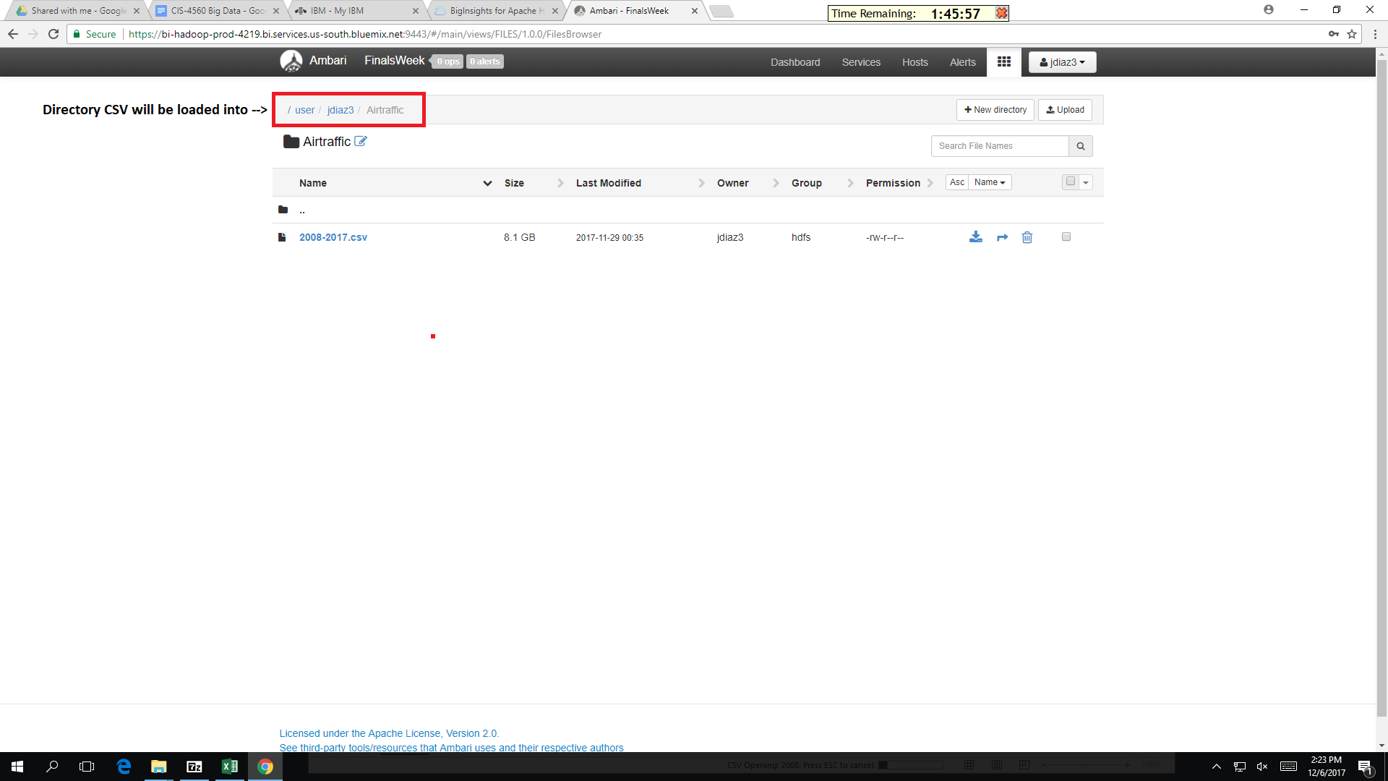

6. Once the data CSV has been uploaded to HDFS through Ambari File Browser, we can login to our BigInsights Cluster through SSH. Input the URL to your cluster in your SSH client. If using PuTTY it should look like the picture below.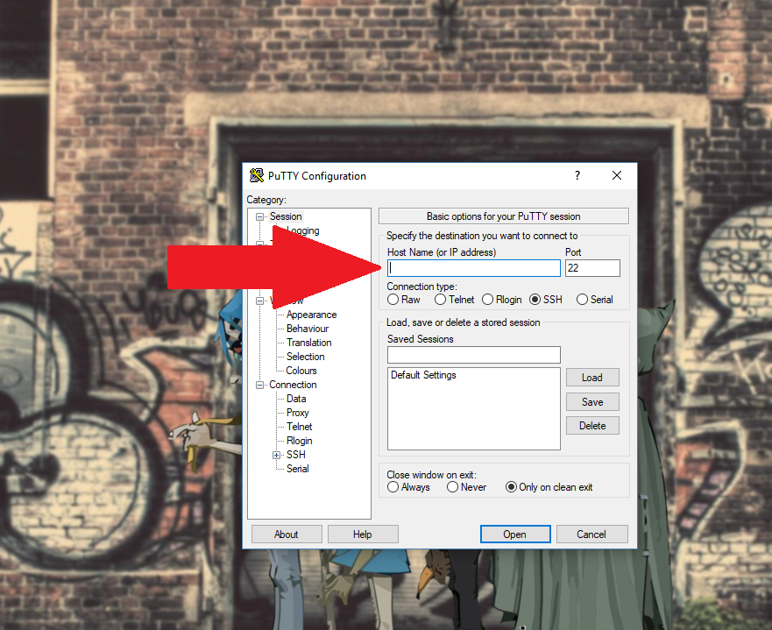

7. After logging in, type Hive into the command line to enable the Hive CLI, that will allow you to create the tables necessary.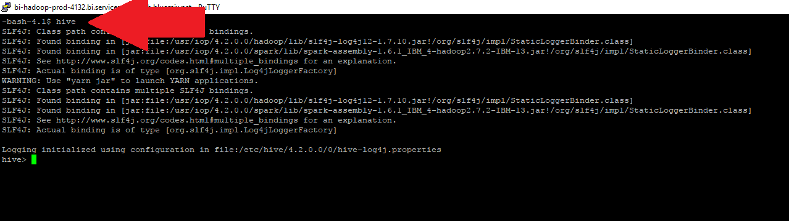

8. Next input the following query to create a table for the data you uploaded to HDFS. Replace <username> with your user name and <data directory> with the name of directory you uploaded to.

**CREATE EXTERNAL TABLE IF NOT EXISTS AirtrafficData**

**(**

**year INT,month INT,day_of_month INT,day_of_week INT,unique_carrier STRING,tail_num STRING,fl_num STRING,origin_airport_id STRING,dest_airport_id STRING,dest STRING,crs_dep_time INT,dep_time INT,dep_delay INT,taxi_out INT,taxi_in INT,crs_arr_time INT,arr_time INT,arr_delay INT,cancelled INT,cancellation_code CHAR(1),diverted INT,crs_elapsed_time INT,actual_elapsed_time INT,air_time INT,carrier_delay INT,weather_delay INT,nas_delay INT,security_delay INT,late_aircraft_delay INT**

**)**

**ROW FORMAT DELIMITED**

**FIELDS TERMINATED BY ','**

**STORED AS TEXTFILE**

**location '/user/<username>/<data directory>';**

**CREATE EXTERNAL TABLE IF NOT EXISTS IDs**

**(**

**Code STRING,**

**City STRING,**

**Location STRING,**

**Name String**

**)**

**COMMENT 'Airport Codes to Cities/Airports'**

**ROW FORMAT DELIMITED**

**FIELDS TERMINATED BY ','**

**STORED AS TEXTFILE**

**location '/user/<username>/<data directory>';**

9. To verify the data is in place, using this query will display the average departure delay per airport in 2017.

**SELECT airtrafficdata.origin_airport_id, avg(airtrafficdata.dep_delay), ids.city, ids.location, ids.name FROM airtrafficdata JOIN ids WHERE airtrafficdata.origin_airport_id = ids.code GROUP BY airtrafficdata.origin_airport_id, ids.city, ids.location, ids.name;**

You can get CSV output in with this version

**INSERT OVERWRITE DIRECTORY '/user/<username>/<data directory>';' ROW FORMAT DELIMITED FIELDS TERMINATED BY ',' STORED AS TEXTFILE SELECT airtrafficdata.origin_airport_id, avg(airtrafficdata.dep_delay), ids.city, ids.location, ids.name FROM airtrafficdata JOIN ids WHERE airtrafficdata.origin_airport_id = ids.code GROUP BY airtrafficdata.origin_airport_id, ids.city, ids.location, ids.name;**

10. Output should look like this once downloaded from Ambari.

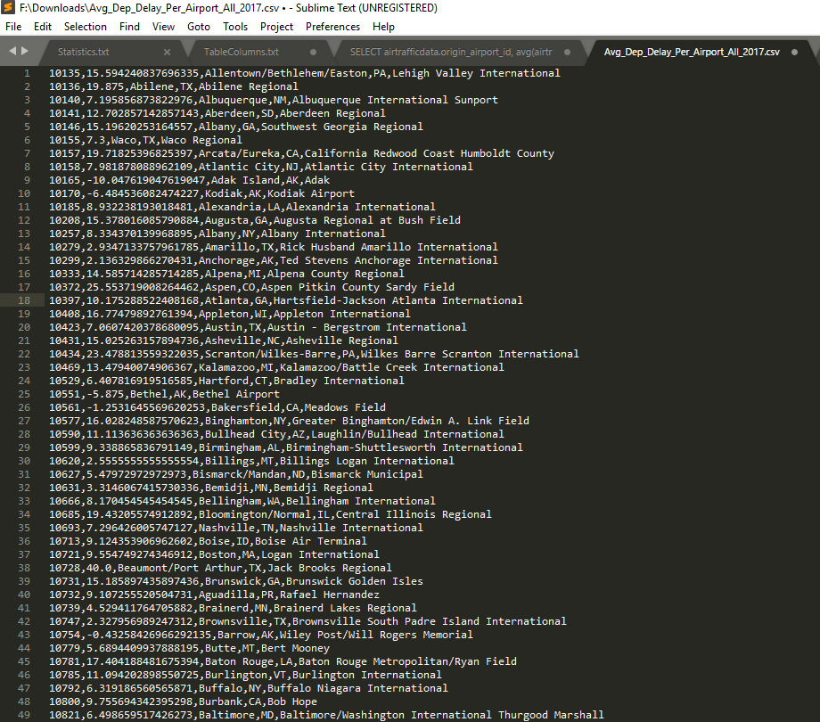

11. Excel Visualization of average departure delay for airports in the US

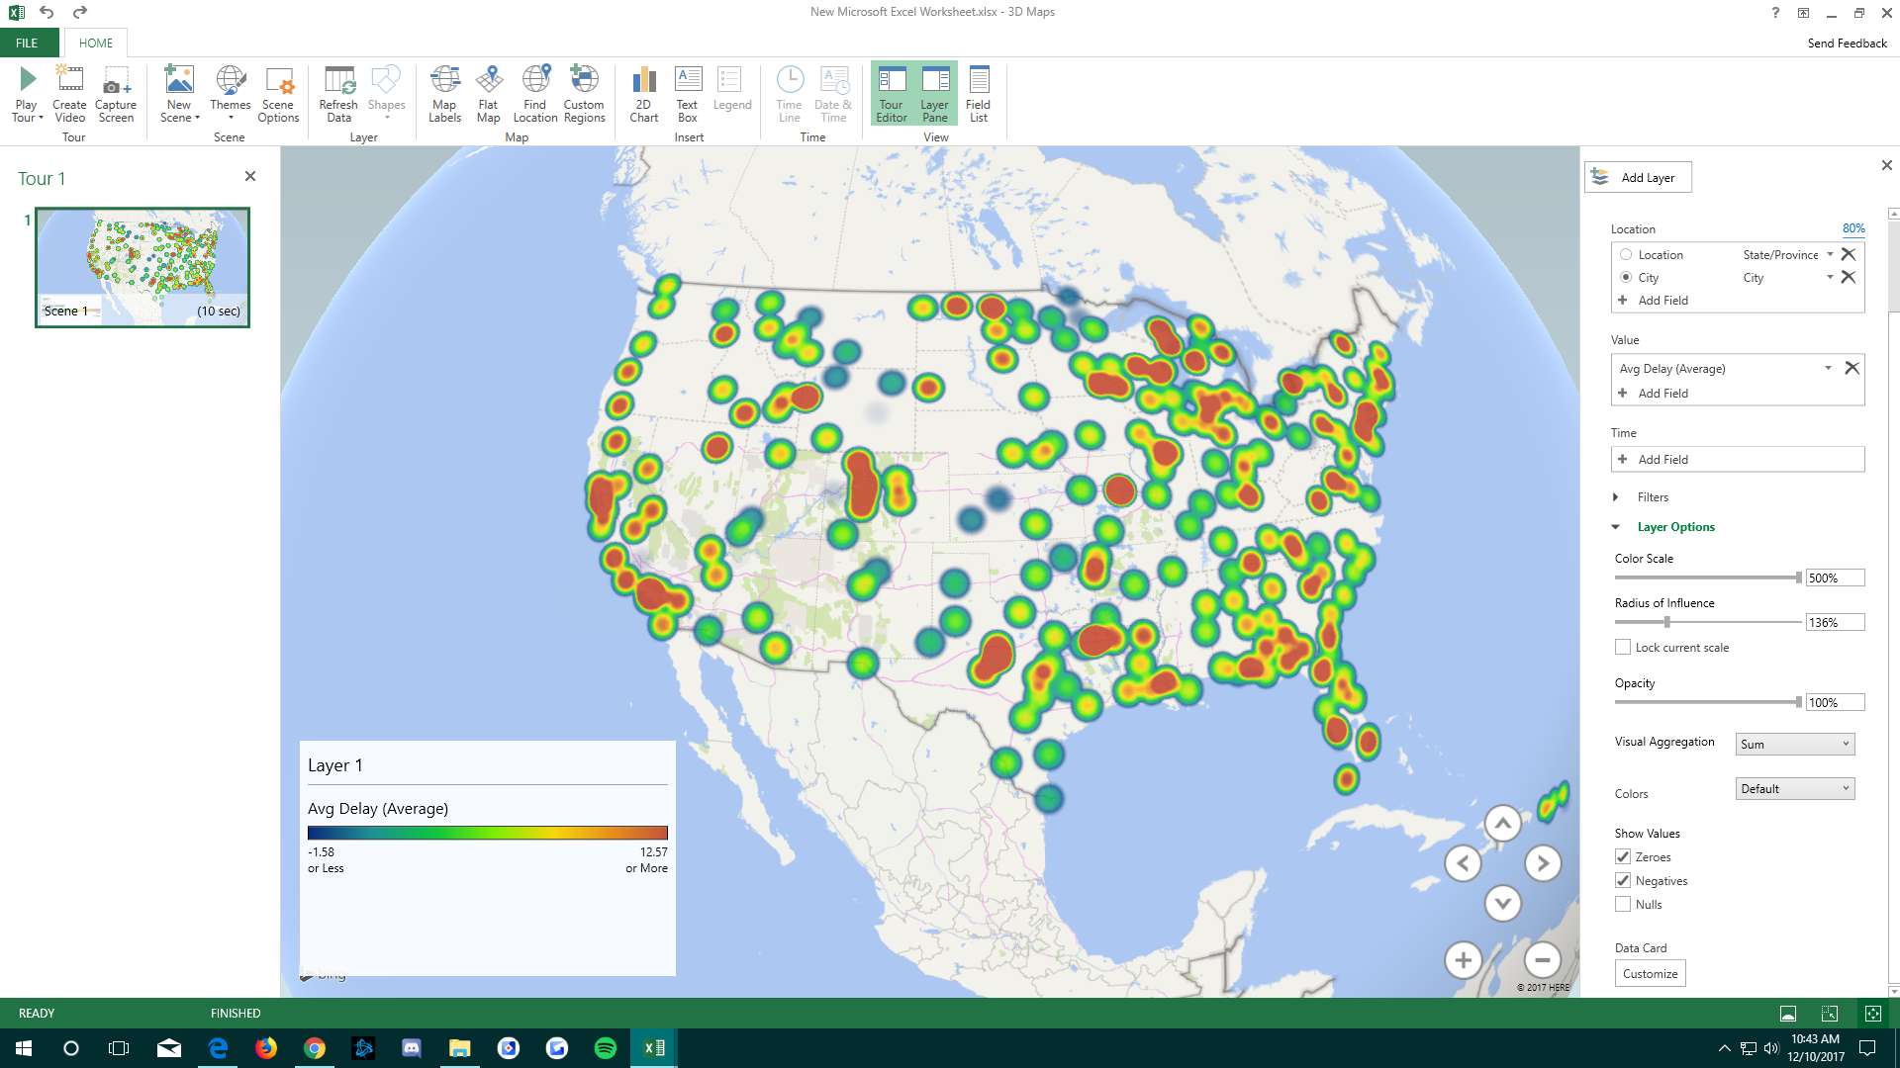

**REFERENCES**

* Data URL: <https://www.transtats.bts.gov/DL_SelectFields.asp?Table_ID=>
* GIthub URL: <https://github.com/diazjordi/CIS-4560-AirTraffic-Data>
* Reference Materials:
* <https://cwiki.apache.org/confluence/display/Hive/LanguageManual>
* <https://www.ibm.com/support/knowledgecenter/v1/sso/login?redirect_url=https%3A%2F%2Fwww.ibm.com%2Fsupport%2Fknowledgecenter%2Fen%2FSSPT3X_4.2.0%2Fcom.ibm.swg.im.infosphere.biginsights.welcome.doc%2Fdoc%2Fwelcome.html>
* <https://docs.hortonworks.com/HDPDocuments/Ambari/Ambari-2.2.2.0/index.html>